Project Handbook.

Date Ending: Feb 4th 2022.

This week I evaluated temperature and humidity sensors DHT11 & DHT22.

# DHT11

The DHT11 is a basic, ultra low-cost digital temperature and humidity sensor.

It uses a capacitive humidity sensor and a thermistor to measure the surrounding air and spits out a digital signal on the data pin (no analog input pins needed).

It's fairly simple to use but requires careful timing to grab data.

The only real downside of this sensor is you can only get new data from it once every 2 seconds, so when using our library, sensor readings can be up to 2 seconds old.

|  |
| --- |
|  |
| (Campbell, 2016) |

In the image above there are 2 different types of DHT11, both are the same only 1 pin is not used in the 4 pin module.

I can’t say why the third pin is not used, but when I looked up its datasheet it is also marked as ground.

The typical wiring diagram to the raspberry pi is as follows:

|  |
| --- |
|  |
|  |
| (Campbell, 2016) |

When I wired up each sensor I could only get the 4 pin one working after looking up a very specialized python library.

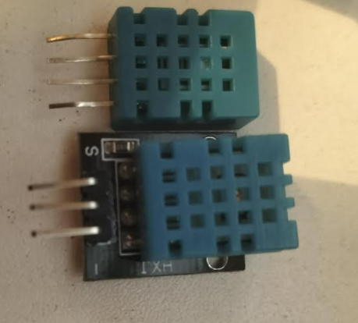

Some of the benefits of using the DHT11 include:

* Low cost €5.74
* 3 to 5V power and I/O
* 2.5mA max current use during conversion (while requesting data)
* Good for 20-80% humidity readings with 5% accuracy
* Good for 0-50°C temperature readings ±2°C accuracy
* No more than 1 Hz sampling rate (once every second)
* Body size 15.5mm x 12mm x 5.5mm
* 4 pins with 0.1" spacing

# DHT22

# Python Library.

I evaluated numerous python code, only to find that the designer of this sensor has his original code marked obsolete, and that there is a new library available and a very spec aliased way of downloading it and installing it.

So if you try download and install the “Adafruit_DHT11” library using pythons pip install, this wont work.

You have to install a “Circuit Python” Library.

|  |
| --- |
|  |
| (Anon., 2012) |

When the application code was ran, it had negative results for the 3 pin DHT11, but worked wonderful for the 4 pin DHT11.

The reasoning behind this is I believe that the 3 pin was badly manufactured, upon a visual inspection there were parts burnt on the P.C.B

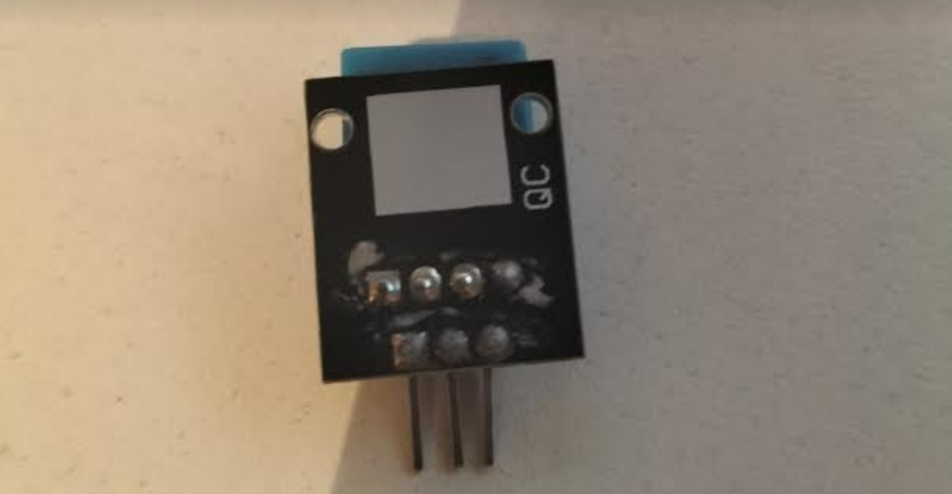

.

# DHT22

The DHT22 is also known as AM2302 or RHT03, it includes a capacitive humidity sensor and a high precision temperature sensor. It uses dedicated digital module acquisition technology and temperature and humidity sensing technology to ensure high reliability and excellent long-term stability.

The DHT22 also has a capacitive sensing element and a high precision temperature measuring element connected to a high-performance 8-bit microcontroller. Thus, it has the advantages of excellent quality, ultra-fast response, strong anti-interference ability, and high-cost performance

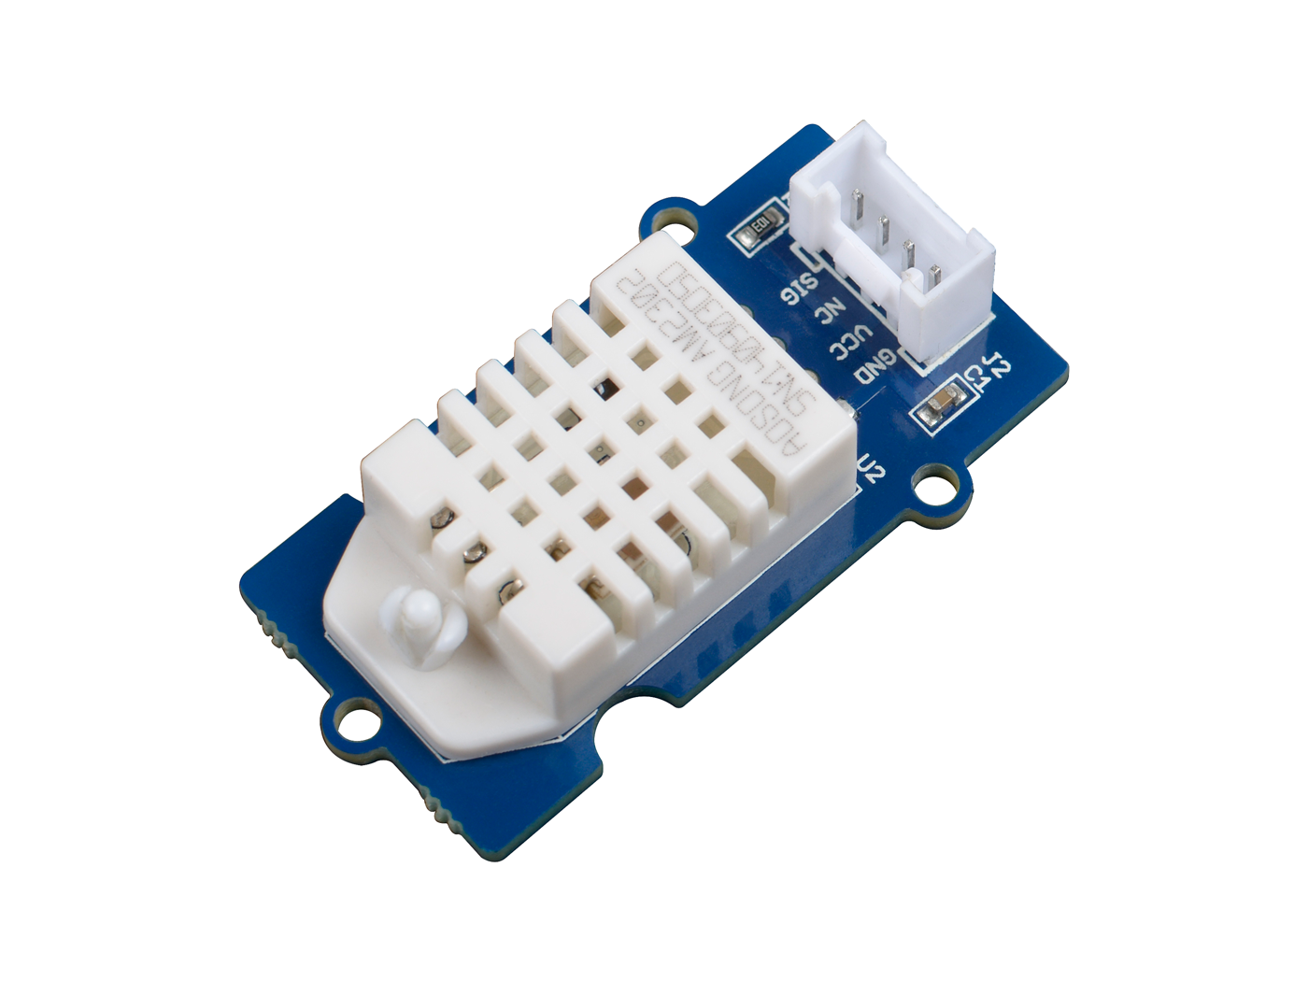

# DHT11 vs DHT22.

When we look at both sensors we need to look at the differences between both.

**Temperature Range**

DHT11: -20 to 60℃

DHT22: -40 to 80℃

**Temperature Accuracy**

DHT11: ±2%

DHT22: ±0.5%

**Humidity Range**

DHT11: 5 to 95% RH

DHT22: 0 to 100%RH

**Humidity Accuracy**

DHT11: ±5%

DHT22: ±2%

**Cost**

DHT11: $5.90

DHT22: $9.90

# Weekly Results and Summary.

# Bibliography

Anon., 2012. *learn.adafruit.com.* [Online]   
Available at: https://learn.adafruit.com/dht-humidity-sensing-on-raspberry-pi-with-gdocs-logging/python-setup  
[Accessed 30 01 2022].

Campbell, S., 2016. *how-to-set-up-the-dht11-humidity-sensor-on-the-raspberry-pi.* [Online]   
Available at: https://www.circuitbasics.com/how-to-set-up-the-dht11-humidity-sensor-on-the-raspberry-pi/  
[Accessed 30 January 2022].